1-4 Assignment: Preparing Your TI Board

Paloma Rodriguez

CS-350 : Emerging Sys & Tech

October 24th, 2023

**Write a brief explanation of the process you followed and any challenges you faced. Were you able to overcome these challenges? If so, how? Are there any areas where you are still having difficulty? This is your opportunity to receive help on the installation process from your instructor, so be as clear in your explanation as possible and be sure to ask any remaining questions you have.**

Following the YouTube video and going into the link ti.dev.com/downloads and then immediately running into an error where there was just a blank white page and message saying “cannot get downloads”, I thought to myself “here we go again”! I have to laugh to get over obstacles because taking it too seriously just makes it very much unenjoyable. After a quick Google search, I found the downloads available on the Texas Instrument website and found the CCS application and downloaded, after that, the video was pretty accurate and was smooth sailing. I downloaded the SDK SimpleLink which did nothing once it was done downloading so I was a bit confused but moved onto the next step and opened CCS and started following the guide. Then when getting going there was no “Software” tab on the left pane, after some digging, I found the “SimpleLink CC32xx SDK” under the “Wireless Connectivity” tab and then under “Embedded Software”! Then went back to the guide and noticed there was no checkmark, followed the guide which is spot at this point and installed the SDK to ensure the checkmark would appear! When on step 11. I did get this error as well when importing the pmw file :

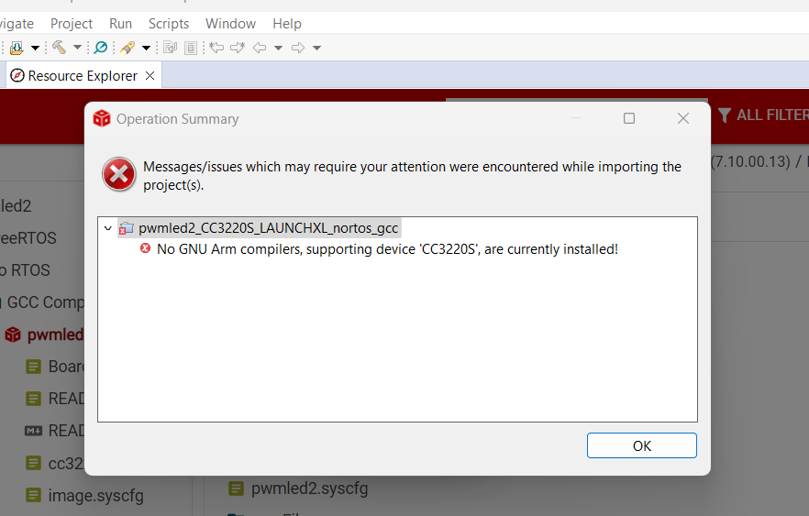

And now this is where I am stuck! I can't seem to locate where the GNU Arm compiler is and how to install it. The board is blinking like the assignment asked for but it was blinking when I simply plugged into the computer. When you review my assignment and get a chance please feel free to reach out to me to get past this part please!